Research Article
Effect of adding titanium dioxide nanoparticles on antimicrobial activity and surface detail reproduction of dental alginate
Ranj A. Omer ^{1*} , Hoshang Kh. Abdel-Rahman² , Mahabad M. Saleh ² , Sazgar S.Q. Al-Hawezi ³, Fahd S. Ikram⁵
- Gasha Technical Institute, Department of Dental Technology, Iraq.
- Department of Prosthodontics, College of Dentistry, Hawler Medical University, Iraq.
- Department of Conservative Dentistry, College of Dentistry, Hawler Medical University, Iraq.
- Department of Prosthodontics, College of Dentistry, Hawler Medical University, Iraq.
* Correspondence: dentist_46@yahoo.com

Received date: 09-05-2022
Accepted date: 10-06-2022
Published date: 15-03-2023

Copyright: © 2022 by the authors. Submitted for possible open access publication under the terms and conditions of the Creative Commons Attribution (CC BY) license (https://creativecommons.org/licenses/by/4.0/).
https://doi.org/10.26477/jbcd.v35i1.3313

Abstract: Most dental works require a diagnostic impression; alginate is contemplated as the most popular material used for this purpose. Titanium dioxide nanoparticles show evidence of antimicrobial activity in the recent era, for this purpose, this study aimed to evaluate the effect of adding Titanium dioxide nanoparticles on antimicrobial activity and surface detail reproduction of alginate impression material. Materials and methods: Titanium dioxide nanoparticles (purity = 99%, size= 20nm) was added to alginate at three different concentrations (2%, 3% and 5%). 84 samples were prepared in total. Samples were tested for antimicrobial activity using a disc diffusion test, and surface detail reproduction was done using (ISO 21563:2021). One-way ANOVA and independent sample t-test were used for data analysis through SPSS software. Results: for the antimicrobial test, inhibition zones for Streptococcus mutans and Candida albicans showed significant changes concerning the alteration in Titanium dioxide nanoparticle concentrations. The inhibition zone significantly increased with an increase in the percentage of Titanium dioxide nanoparticles. The mean of the inhibition zone for S. mutans was superior to C. albicans and the difference was statistically significant. Regarding surface detail reproduction, the control group, 2% and 3% groups manifested very similar results, only the group to which 5% of Titanium dioxide nanoparticles were added showed a decline in detail reproduction when compared to the other three groups. Conclusion: Within the limitation of this study, we can conclude that the antimicrobial activity against S mutans and C. albicans were significantly increased in modified groups, and this escalation was directly linked to the increase in Titanium dioxide nanoparticles concentration. In contrast, the surface detail reproduction was decreased when adding 5% Titanium dioxide nanoparticles to alginate.
Keywords: alginate, surface detail, nanoparticle, candida albicans.

Introduction
Dental impression is a negative replication of hard and soft tissues in the mouth from which a positive reproduction (dental cast) can be formed¹.
Alginate is a biomaterial from a family of irreversible hydrocolloid that has served dental practice for almost century².They were the first elastic impression material to be used in dentistry that provided high detail even under the presence of undercuts³. Being economical, easy to manipulate, and better tolerance by the patient has put alginate in the utmost utilized material in the field of dentistry in contrast to other impression materials such as silicon⁴.
All types of irreversible hydrocolloids have a hydrophilic nature making them susceptible to microbial retention⁵. It is a well-known fact that the human oral cavity is a favourable host to many microbial agents, during the impression-making procedure the oral cavity fluid could adhere to the impression materials⁶. Therefore, they may increase the susceptibility of cross infection⁷. To overcome this point, many disinfection methods have been used such as spraying and immersing. Unfortunately, both methods are time-consuming and may compromise some of the mechanical properties of the alginate⁸.
During the last decade, the use of nanoparticles has become prevalent in the design and development of many dental materials since they can provide a unique combination of properties⁹. Due to the small size of the nanoparticles, they can provide a high surface area to volume ratio compared to particles of the same material¹⁰. This property gives them great attention in the present century as they possess defined mechanical, chemical, and optical properties crafting them into a suitable candidate for various applications¹¹.
Many studies proved that nanoparticles could control the formation of biofilms as they possess biocidal and anti-adhesive properties. For this purpose, silver, copper, zinc, magnesium, titanium, and their oxides have been used as antimicrobial agents in many dental materials¹².
It was proven that TiO₂ NPs possess good antibacterial activity against S. mutans¹³, without deteriorating the mechanical and physical properties¹³⁻¹⁵.
Due to their imperfect properties, alginate remains an active material for research. The purpose of this study is therefore to evaluate the antimicrobial property of dental alginate incorporated with TiO₂NPs against S. mutans and C. albicans, in addition to the surface detail reproduction after this modification.
Materials and Methods
To confirm the identity of the planned TiO₂NPs for use in this study, X-ray Diffraction (XRD) analysis was performed before starting sample preparations.
X-ray diffraction is a powerful non-destructive analytical method that is used to determine the structure and composition of unknown nanomaterials^{16,17}.
XRD test was performed using PANalytical X’pert powder (Figure 1.a) with Cu-Kα x-ray source, a wavelength of λ=1.54060$\dot{A}$ was used. The TiO₂NPs were deposited on to the specimen holder (Figure 1. b) and packed using a glass slide. The NPs inside the sample holder were loaded into the XRD machine and diffraction data was recorded at 2θ range from 10° to 79.9950° with step size 0.0100° per 0.5s. Low scan speed was elected to provide higher sensitivity for the recognition of impurities¹⁸.
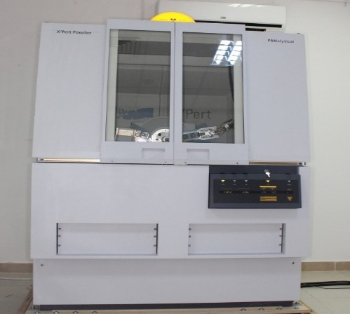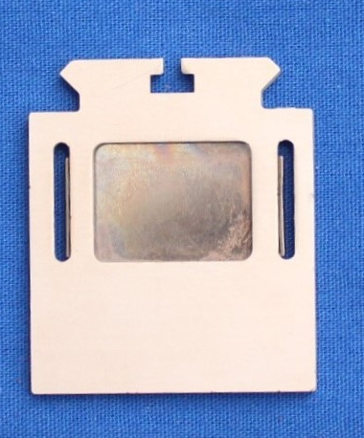
Figure 1: a) PANalytical X’pert powder b) specimen holder

The PANalytical software was used to compare X-ray XRD patterns to identify the NPs. The result of the analysis identified the sample as TiO₂ and its diffraction pattern are shown in figure (2):
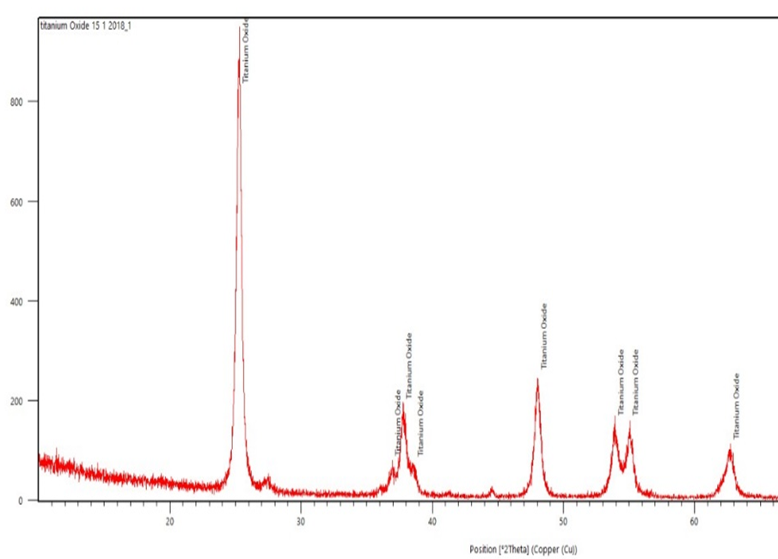
Figure 2: XRD pattern for Titanium oxide nanoparticles

After confirming the identity of the chosen TiO₂NPs, a pilot study was done by FTIR analysis to reveal any possible chemical structure changes (alteration of functional groups) after adding (2%, 3% and 5%) of TiO₂NPs to the alginate, control and modified groups were analysed by the FTIR spectroscopy (Shimadzu 8400, Japan). The result (Figure 3) provided a clear clue that the in cooperation of TiO₂NPs at all concentrations doesn’t induce any significant change in the main functional groups' structure for the (SI-O-SI group, C-O-C group, O-H group and C-H group) which was present in the unmodified alginate as the stretching and bending of the peaks did not alter after the addition of TiO₂NPs.
The only detected change was the increase in the percentage of IR transmittance which was detected only in the 5% TiO₂NPs group, indicating the weakening of the bonds between the alginate molecules.
Similar to the control group, sharp, strong peaks at 619.21 cm⁻¹, 669.83 cm⁻¹ and 793.54 cm⁻¹ for SI-O-SI bands, also the peak at 1078.81 cm⁻¹ for C-O-C bands were observed in all modified groups indicating that the added TiO₂NPs does not interact with the available structural bonds in the alginate, this finding agrees with Skocaj et al ¹⁹ who stated that TiO₂NPs considered as a chemically inert material.
The weak sharp bending peak of the O-H group at 1621.88 cm⁻¹ was very similar in control, 2% TiO₂NPs and 3% TiO₂NPs as the IR transmittance located at the same levels, but for the 5% group although the bands located at the same wavelength level but, the IR transmittance increased which is an indication that the higher TiO₂NPs concentration might cause weakening of these bands due to the agglomeration of the TiO₂NPs²⁰.
The weak stretch peak of the C-H group at 2924.61 cm⁻¹, also the strong stretch peak of the O-H group at 3421.89 cm⁻¹ and 3527.51 cm⁻¹ for the control, 2% TiO₂NPs and 3% TiO₂NPs groups was almost identical but again there was a difference in the IR transmittance rate in which for the 5% TiO₂NPs group was 80%, while for the former three groups at about 50%, this might be due to formation of small gaps between these molecular groups band which ultimately caused the bonds to become weaker²⁰ thus the IR easily penetrated the samples contained a higher percentage of 5%TiO₂ NPs.
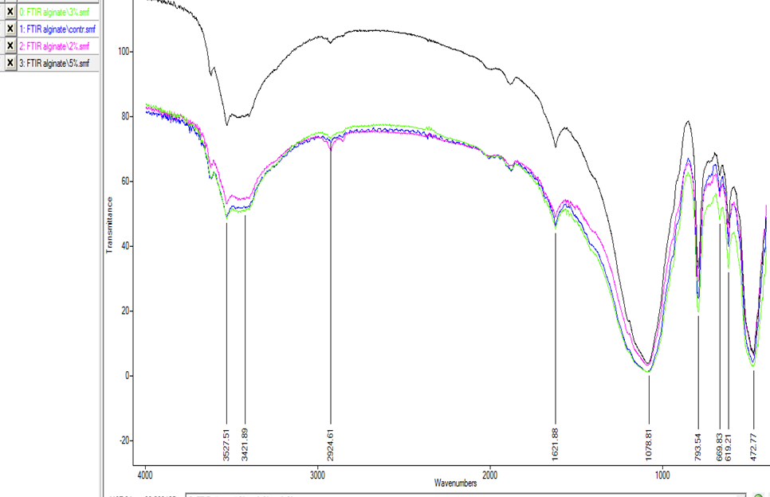
Figure 3: FTIR analysis of Alginate (Blue =Control, Pink=2%, Green =3%, Black= 5%)

Study design and sample preparation
In the present study, 84 samples were prepared from Alginplus (Major- ISO 21563. Italy) extra high precision alginate impression material. Antimicrobial activity against S. mutans (n=28) and C. albicans (n=28) in addition to surface detail reproduction (n=28) were tested. One control group and three modified groups to which (2%, 3% and 5%) spheric shaped TiO₂NPs were added respectively to the alginate have been studied, each group consisting of seven samples.
Digital electronic balance (OHAUS GmbH- Switzerland) with precise accuracy of 0.0001 mg was used to weigh the alginate powder and the amount of TiO₂NPs powder.
The samples were prepared by mixing the blend of both powders (Alginate and TiO₂NPs) with a premeasured volume of distilled water as recommended by the manufacturer by using an automatic alginate mixer (Cavex- Netherlands) for 10 seconds.
Antimicrobial test
A disc diffusion test was used to investigate the antimicrobial activity released from the tested alginate specimens. For this purpose, two main oral pathogens namely S. mutans ATCC 25175 and C. albicans ATCC 10231 yeasts were chosen.
The S. mutans bacteria were cultivated on blood agar media. The culture media was prepared according to the recommended protocol for S. mutans. Seven Petri dishes were used, and in each petri dish, four specimens were placed at equal distances from each other, marked with numbers 1, 2, 3 and 4 representing the control, 2%, 3% and 5% groups respectively and incubated aerobically at 37°C for 24 hours.
For the C. albicans ATCC 10231, Sabouraud Dextrose Agar was used for growing and cultivation²¹. The protocols from Antifungal susceptibility testing of the National Committee for Clinical Laboratory Standards (NCCLS) and Manual of Antimicrobial Susceptibility Testing were followed^{22,23}. The seven Petri dishes containing samples were incubated for 24 hours.
The measurement of inhibition zones for both pathogens was performed using scientific image analysis known as Image J software²⁴.
After completion of 24 hours incubation, the Petri dishes were taken out from the incubator, and images were taken at 90º with a reference of a ruler for calibration of image J software. Inhibition zones were measured around the ingots at six different positions.
For the entire procedure, the working environment was conditioned under Bio air Top safe with continuous air ventilation and a Bunsen burner that was turned on near the working field to prevent contamination of the testing components by airborne pollutants^{25.26}.
Surface detail reproduction
A stainless-steel die with three scribed parallel lines ISO 21563: 2021²⁷ is used for surface detail reproduction. The widths of these lines were 20-μm, 50-μm and 75-μm respectively. A stainless-steel ring was placed on top of the steel die; the mixed alginate was poured inside the ring over the testing mould. A glass slab was then placed on top of the ring and a one-kilogram weight was positioned upon the slab for 10 minutes. Then, the samples were carefully removed from the mould and immediately examined with a digital microscope UM012C (5M 300X with 8 LEDs- China). Prior to the measurement procedure, the microscope eyepieces lens was calibrated for precise measurements of the samples.
Specimens were reported to either pass (1) or fail (0) the test based on their ability to capture the entire length of the scribed 20-um line over the full length of 25mm distance between the cross line^{27,28}. The surfaces were assessed according to the ranking system established by Owen²⁹ which are:
Score 1: Line reproduced clearly and sharply over the entire length between the marks.
Score 2: Line clear over more than 50% of length, or line indistinct over less than 50% of length, the line appears to be reproduced well over the entire length, but not sharply.
Score 3: Line clear over less than 50% of length, line indistinct over more than 50% of length, or line visible over entire length but blemished not sharp.
Score 4: Line is not reproduced over the entire length; rough, blemished, pitted.
Statistical analysis
Statistical Package for Social Sciences (SPSS, version 23.0) and Microsoft Office Excel were used for statistical analysis. Descriptive statistics for frequency, mean, and standard deviation. Student T-test was used for comparisons between two independent groups, in addition to One-way ANOVA and post hoc test for multiple comparisons. The p<0.05 value was considered statistically significant.
Results
The obtained results from the antimicrobial test showed that the control group exhibited the least antimicrobial activity; furthermore, it was observed that the inhibitory effect against both pathogens was directly linked to the increase in the concentration of TiO₂NPs as shown in Figure (4)
The inhibitory effect of the modified alginate against S. mutans was more dominant compared to C. albicans which revealed higher resistance to the added TiO₂NPs at the same concentrations.

Figure 4: Mean inhibition zone for S. mutans and C.albicans
For S. mutans, the results of One-way ANOVA revealed a statistically significant difference (p < 0.05) in the inhibition zone measurements as shown in Table (1).
Table 1: One-way ANOVA test for S.mutans
Group | N | Mean+SD | 95% CI for mean  Lower band Upper band |  | F | Sig  P-Value
Control | 7 | 0.19014 (0.00661) | 0.18402 | 0.19626 | 534.957 | 0.000
2%TiO₂NPs | 7 | 1.89043 (0.12906) | 1.77106 | 2.00979
3%TiO₂NPs | 7 | 3.11357 (0.37468) | 2.76704 | 3.46010
5%TiO₂NPs | 7 | 4.45529 (0.12333) | 4.34122 | 4.56935
Total | 28 | 2.41236 (1.61205) | 1.78727 | 3.03745

Post hoc (LSD) test for multiple comparisons depicted a statistically significantly different between the groups in such a way that the added TiO₂NPs improved the antibacterial activity of the used alginate in all used concentrations as shown in Table (2).
Table 2: Post hoc test (LSD- multiple comparisons) for S. mutans
Group I | Group J | Mean Difference (I-J) | 95% CI for mean  Lower band Upper band |  | Sig  P-value
Control | 2% Tio₂NPs | -1.700286* | -1.92925 | -1.47132 | 0.000
 | 3% Tio₂NPs | -2.923429* | -3.15239 | -2.69446 | 0.000
 | 5% Tio₂NPs | -4.265143* | -4.49411 | -4.03618 | 0.000
2% Tio₂NPs | 3% Tio₂NPs | -1.223143* | -1.45211 | -0.99418 | 0.000
 | 5% Tio₂NPs | -2.564857* | -2.79382 | -2.33589 | 0.000
3% Tio₂NPs | 5% Tio₂NPs | -1.341714* | -1.57068 | -1.11275 | 0.000

Regarding C. albicans, the obtained results were identical to the results of S. mutans as there was a statistically highly significant increase in the antifungal activity of the alginate in the modified groups. The inhibition zone was more dominant at the highest percentage (5%) of used TiO₂NPs compared to the 2% and 3% groups. The control group possessed a minimum inhibition zone as shown in Table (3).
Table 3: One-way ANOVA test for C. albicans
Group | N |  | Mean+SD |  | 95% CI for mean  Lower band upper band |  |  | F |  | Sig  P-value
Control |  | 7 |  | 0.20086 (0.00470) |  | 0.19651 | 0.20521 |  | 926.760 |  | 0.000
2% Tio₂NPs |  | 7 |  | 1.22071 (0.06380) |  | 1.16170 | 1.27973
3% Tio₂NPs |  | 7 |  | 2.21943(0.14397) |  | 2.08627 | 2.35258
5% Tio₂NPs |  | 7 |  | 2.72629 (0.11391) |  | 2.62093 | 2.83164
Total |  | 28 |  | 1.59182 (0.99070) |  | 1.20766 | 1.97598
Post hoc test for multiple comparisons between the groups showed the presence of highly significant difference (p < 0.001) between the control group and the other groups as well as between the groups themselves as shown in table (4).
Table 4: Post hoc test (LSD- multiple comparisons) for S.mutans C.albicans
Group I | Group J | Mean Difference (I-J) | 95% CI for mean  Lower band Upper band |  | Sig  P-value
Control | 2% Tio₂NPs | -1.019857* | -1.12710 | -0.91261 | 0.000
 | 3% Tio₂NPs | -2.018571* | -2.12582 | -1.91133 | 0.000
 | 5% Tio₂NPs | -2.525429* | -2.63267 | -2.41818 | 0.000
2% Tio₂NPs | 3% Tio₂NPs | -0.998714* | -1.10596 | -0.89147 | 0.000
 | 5% Tio₂NPs | -1.505571* | -1.61282 | -1.39833 | 0.000
3% Tio₂NPs | 5% Tio₂NPs | -0.506857* | -0.61410 | -0.39961 | 0.000

An Independent sample t-test was used to evaluate whether S. mutans and C. albicans differ significantly in their inhibition zone. The result specified that the mean of the inhibition zone for S. mutans and C. albicans was statistically significant as shown in Table (5). The means indicated that S. mutans (M = 2.41236, SD = 1.61205) showed significantly more inhibition zone than C. albicans (M=1.5917, SD=0.99070).
Table 5: Independed Student T-test for S. mutans and C. albicans.
 | Levene's Test for Equality of Variances |  | t-test for Equality of Means
 | F | Sig. | t | df | Sig.(2 tailed) | Mean Difference | Std. Error Difference
Equal variances assumed.  Equal variances not assumed | 8.204 | 0.006 | 2.295 | 54 | 0.026 | 0.820536 | 0.357582
 |  |  | 2.295 | 44.849 | 0.026 | 0.820536 | 0.357582

Surface detail reproduction
The alginate used in this study is branded as an irreversible hydrocolloid material that satisfies ISO 21563. All the tested groups efficiently and sharply recorded the 75-µm line in the entire length thus satisfying Owen’s score 1. Regarding 50-µm line, the control group, 2% and 3% groups reproduced that line on the alginate samples surface with Owens score 2 except for 5% TiO₂NPs group that fall into Owens score 3.
As mentioned previously, due to extra high quality of the used alginate in this study, the reproduction of the 20-um line was selected and considered as the base line for comparison between the groups. The group that was altered by addition of 5% of TiO₂NPs failed to record the 20-µm line (Figure 5), while the remaining three groups reproduced 20-µm line and this ability is considered as an equivalent to the detail reproduction of the addition silicones according to ISO specifications 4823³⁰.

Figure 5: Surface detail reproduction
Discussion
Infection control is a fundamental procedure in dental practice. It is documented that there are about 750 million microorganisms in only 1 mL of the saliva of a healthy person³¹.
According to many researchers, spherical-shaped nanoparticles with sizes 15-50nm exhibit maximum antimicrobial properties³². Due to this, spheric-shaped 20 nm TiO₂NPs were chosen for this study. The result of the inhibition zone for S. mutans showed a significant increase when the percentage of TiO₂NPs increased, a similar finding was obtained in a study by Al-Hawezi¹³ when TiO2NPs were in cooperated into a flowable dental composite resin and agreed with the result obtained in studies done for testing the effect of silver nanoparticles on S. mutans^{33,34}.
The antibacterial activity of TiO₂NPs is practically due to a reaction of the high surface energy TiO₂NPs with water. TiO₂NPs release free radicals which are considered a potent oxidizing agent (Reactive oxygen species) that ultimately destroy the cell membrane³⁵ or alternatively, in the absence of light, direct contact and adsorption of cells onto TiO2NPs may cause a loss of bacterial cell membrane³⁶.
Additionally, reports in the literature have shown that electrostatic attraction plays a great role in the bactericidal effect of the material³⁷. This attraction probably overcomes other factors, such as the size and shape of NPs which can influence bacterial cell death³⁸.
The antifungal effect of TiO2NPs against C. albicnas was obvious in the modified groups when compared to control group, this finding agrees with results of a study³⁹ who found that up to 65% of the C. albicans were killed after exposure to 100 μg/mL of TiO2NPs. A similar results was concluded with of Kermani et al⁴⁰ who found that higher percentage of the titanium and zinc oxide nanoparticles increased their toxicity.
It was documented that TiO2NPs cause C. albicans yeast cell death by producing intracellular reactive oxygen species (ROS), this in turn causes oxidation of the Coenzyme-A and peroxidation of lipids which subsequently decreases respiratory activity and ultimately causes cell death⁴¹. Another explanation for the antifungal activity of TiO2NP_{S}, is the tear of the fungi cell membrane that disturb its integrity, causing loss of intracellular substances ⁴².
Impression-making is a routine in the dental practice, for this purpose, a variety of impression materials are available to capture oral cavity structures, the final decision for the selection of these products is usually based on the required type of dental treatment and clinician’s preference⁴³.
Surface detail reproduction is considered fundamental criteria for any irreversible hydrocolloid material, the latest ISO 21563 and ADA specification 18 is used as a standard protocol for measuring this property.
The results of the present study were similar to another study ⁴⁴ when they found no adverse effect of incorporating up to 1000 ppm of silver nanoparticle on the surface detail reproduction of alginate. This could be the result that the TiO₂NPs were small (20nm) thus the particles were evenly distributed within the alginate matrix and did not influence the intermolecular bond. In addition, these nanoparticles are considered an inert material and do not induce any chemical structure alteration, this fact was supported by the FTIR analysis results.
At 5% TiO₂NPs, caused deterioration of the surface detail reproduction and it was impossible to record the 20-μm line, this may be due to agglomeration of the used TiO₂NPs inside the alginate matrix because of their high surface energy ⁴⁵, this in turn triggered a poor intermolecular bond.
According to obtained data, the requirements were met for irreversible hydrocolloid material as the tested groups reproduced the 75-µm and 50-µm groove which is considered satisfactory for alginate impression materials^{,46.}
Conclusion
Within the limitation of this study, we can conclude that the addition of TiO2NPs to alginate improved the antimicrobial activity significantly. TiO2NPs are more powerful against S. mutans at the same used concentration. The addition of TiO₂NPs doesn’t compromise the ISO 21563 requirement for surface detail reproduction.

Conflict of interest: None.
References
- Hamalian, T. A., Nasr, E., Chidiac, J.J. Impression Materials in Fixed prosthodontics: influence of choice on clinical procedure. J Prosthodont. 2011; 20(2):153-60.
- Hansson, O., Eklund, J. A historical review of hydrocolloids and an investigation of the dimensional accuracy of the new alginates for crown and bridge impressions when using stock trays. Swed Dent J. 1984; 8(2): 81-95.
- Cervino, G., Fiorillo, L., Herford, A., et al. Alginate Materials and Dental Impression Technique: A Current State of the Art and Application to Dental Practice. Mar Drugs. 2018; 17(1): 18.
- Glenner, R.A. Dental impressions. J Hist Dent. 1997; 45(3): 127–30.
- Samra, R.K. Bhide, S.V. Efficacy of Different Disinfectant Systems on Alginate and Addition Silicone Impression Materials of Indian and International Origin: A Comparative Evaluation. J Indian Prosthodont Soc. 2010; 10(3): 182–189.
- Amalan , K., Ginjupalli, A. Upadhya, N. Evaluation of properties of irreversible hydrocolloid impression materials mixed with disinfectant liquids. Dent Res J (Isfahan). 2013; 10(1): 65-73.
- Jenning, K.J. Samaranayake, L.P. The persistence of microorganisms on impression materials following disinfection. Int J Prosthodont. 1991; 4(4): 382-7.
- Wang, J., Wan, Q., Chao, Y., et al. A self-disinfecting irreversible hydrocolloid impression material mixed with chlorhexidine solution. Angle Orthod. 2007; 77(5): 894-900.
- Mitra, S.B. Nanoparticles for dental materials: synthesis, analysis, and applications. In: Emerging nanotechnologies in dentistry. Elsevier; 2012. p. 15–33.
- Figueroa,, L. A., Morales-Luckie., R. A., Scougall-Vilchis, R.J., et al. Synthesis, characterization and antibacterial activity of copper, nickel and bimetallic Cu–Ni nanoparticles for potential use in dental materials. Progress in Natural Science: Materials International.20114; 24(4): 321-328.
- Khan I, Saeed K, Khan I.. Nanoparticles: Properties, applications and toxicities. Arab J Chem. 2019; 12(7): 908-931.
- Jefferson, K.K. What drives bacteria to produce a biofilm?. FEMS Microbiology Letters. 2004; 236(2): 163–173.
- Al-Hawezi, S.S.Q. The effect of addition of titanium dioxide nanofillers on the properties of flowable composite resin (in vitro study). Ph.D.Thesis. Hawler Medical University, Iraq, 2021.
- Sodagar, A., Akhoundi, M.S.A., Bahador, A, et al. Effect of TiO₂ nanoparticles incorporation on antibacterial properties and shear bond strength of dental composite used in Orthodontics. Dent Press J Orthod. 2017; 22(5): 67–74.
- Ahmed, A.Q. The influence of titanium dioxide nanoparticles (TiO2NPS) incorporation into heat cured soft denture lining material on Candida albicans adherence and some other properties. M.Sc thesis. University of Baghdad, Iraq, 2018..
- Whitfield, P., Mitchell, L. X-ray diffraction analysis of nanoparticles: Recent developments, potential problems and some solutions. Int J Nanosci. 2004; 3(6): 757–63.
- Bunaciu, A.A., UdriŞTioiu, E.G. Aboul-Enein, H.Y. X-ray diffraction: instrumentation and applications. Crit Rev Anal Chem 2015; 45(4): 289–99.
- Ruparelia, J.P., Chatterjee, A.K., Duttagupta, S.P., et al. Strain specificity in antimicrobial activity of silver and copper nanoparticles. Acta Biomater. 2008; 4(3): 707–16
- Skocaj, M., Filipic, M., Petkovic, J., et al. Titanium dioxide in our everyday life; is it safe?. Radiol Oncol. 2011; 45(4): 227-247.
- Abdelrahman, H.K. Al-Sammaraie, S.A.S. Effect of addition of Magnesium Oxide Nanoparticles on surface hardness and tensile bond strength of denture soft liner. IJFMT. 2020; 14(3): 2479-2485.
- Monteiro, D.R., Gorup, L.F., Takamiya, A.S., et al. Silver distribution and release from an antimicrobial denture base resin containing silver colloidal nanoparticles. J Prosthodont. 2012; 21(1): 7–15.
- Pfaller, M.A. National Committee for Clinical Laboratory Standards. Reference method for broth dilution antifungal susceptibility testing of yeasts: approved standard. Wayne, Pa.: National Committee for Clinical Laboratory Standards; 2002.
- Coyle, M.B. American Society for Microbiology. Manual of antimicrobial susceptibility testing. Burnaby, BC: BCIT Imaging Services; 2012.
- Chneider, C.A., Rasband, W.S., Eliceiri, K.W. NIH Image to ImageJ: 25 years of image analysis. Nat Methods. 2012; 9(7): 671–5.
- Bykowski, T. Stevenson, B. Aseptic technique. Current Protocols Microbiol. 2008; 11(1): A-4D.
- Omer, R.A. Ikram, F.S. Evaluation of Antibacterial Effect of Silver and Copper Oxide Nanoparticles in Denture Base Material Against Streptococcus mutans and Escherichia coli. Saudi Dental J. 2019; 6(1):13–20.
- ISO 21563: 2021. Dentistry-Hydrocolloid Impression Material. Geneva, Switzerland: International Organization for Standardization.
- American Dental Association Specification No. 19 .Elastomeric Impression Materials. 2004s
- Owen, C.P. An investigation into the compatibility of some irreversible hydrocolloid impression materials and dental gypsum products: Part II. A refined discriminatory procedure. J Oral Rehabil. 1986; 13(2):147–62.
- ISO 4823: 2021. Dentistry-Elastomeric Impression Material. Geneva, Switzerland: International Organization for Standardization.
- Gupta, S., Rani, S., Garg, S. Infection control knowledge and practice: a cross-sectional survey on dental laboratories in dental institutes of North India. J Indian Prosthodont Soc 2017; 17: 348- 354.
- Courrol, D.S., Lopes, C.R.B., Cordeiro, T.S., et al. Optical properties and antimicrobial effects of silver nanoparticles synthesized by femtosecond laser photoreduction. Optics Laser Technol. 2018; 103: 233–8.
- de Castro DT, Kreve S, Oliveira VC, et al. Development of an impression material with antimicrobial properties for dental application. J Prosthodont. 2019 Oct;28(8):906-12.
- Rajendran, V., Suma, K., Ali, S.A., et al. Antimicrobial Efficacy of Irreversible Hydrocolloid Impression Impregnated with Silver Nanoparticles Compared to Surface Disinfected Impressions - An In vivo Study.
J Pharm Bioallied Sci. 2021; 13(1): S532-6.
- Hu, H., Fan, X., Yin, Y., et al. Mechanisms of titanium dioxide nanoparticle-induced oxidative stress and modulation of plasma glucose in mice. Environ Toxicol. 2019, 34(11): 1221-1235.
- Seil, J.T., Webster, T.J. Antimicrobial applications of nanotechnology: methods and literature. Int J Nanomed, 2012; 7: 2767-2781
- Sondi, I., Salopek-Sondi, B. Silver nanoparticles as antimicrobial agent: a case study on E. coli as a model for Gram-negative bacteria. JCIS Open. 2004; 275(1):177–82.
- Abbaszadegan, A., Ghahramani, Y., Gholami, A., et al. The effect of charge at the surface of silver nanoparticles on antimicrobial activity against gram-positive and gram-negative bacteria: a preliminary study. J Nanomater. 2015; 16(1): 53.
- Ahmad, N.S., Abdullah, N., Yasin, F.M. Antifungal activity of titanium dioxide nanoparticles against Candida albicans. Bio Res. 2019; 14(4): 8866-8878.
- Kermani, S.A., Salari, S., Almani, P.G.N. Comparison of antifungal and cytotoxicity activities of titanium dioxide and zinc oxide nanoparticles with amphotericin B against different Candida species: In vitro evaluation. J Clin Lab Anal. 2021; 35: e23577.
- Haghighi, F., Mohammadi, R.S., Mohammadi, P., et al. Antifungal activity of TiO2 nanoparticles and EDTA on Candida albicans biofilms. Infection, Epidemiology and Microbiology. 2013; 1(1): 33-8
- Kamikawa, Y., Hirabayashi, D., Nagayama, T., et al. In vitro antifungal activity against oral Candida species using a denture base coated with silver nanoparticles. J Nanomater. 2014; 2014: 48.
- Manar, J. Alginate as impression material. J Appl Oral Sci. 2018; 4(3): 300-3.
- Omidkhoda, M., Hasanzadeh, N., Soleimani, F. Antimicrobial and physical properties of alginate impression material incorporated with silver nanoparticles. Dent Res J. 2019; 16(6): 372-376.
- Watson S, Beydoun D, Scott J, et al. Preparation of nanosized crystalline TiO 2 particles at low temperature for photocatalysis. J. Nanopart Res. 2004 Jun;6:193-207.
- American Dental Association Specification No. 18. dental alginate impression materials. 1992.

تأثير إضافة جزيئات ثاني أكسيدالتيتانيوم النانوية على نشاط مضادات الميكروبات ونسخ تفاصيل السطح لمادة الألجينات السنية

الباحثون: رنج ازاد عمر , هوشنك خالد عبدالرحمن , سازكار سربست قاسم الحويزي , مهاباد محمود صالح, فهد سداد اكرام

المستخلص:

الخلفية: معظم أعمال طب الأسنان تتطلب انطباعًا تشخيصيًا ،الجينات هي المادة المستخدمة الأكثر شيوعًا لهذا الغرض. تظهر الجسيمات النانوية لثاني أكسيد التيتانيوم دليلاً على نشاط مضادات الميكروبات في العصر الحديث ، ولهذا الغرض تهدف هذه الدراسة إلى تقييم تأثير إضافة TiO2NPs على النشاط المضاد للميكروبات ونسخ تفاصيل السطح لمادة الانطباع الجينات.

تمت إضافة TiO2NPs (نقاء = 99٪ ، الحجم = 20 نانومتر) إلى الجينات بثلاث تركيزات مختلفة (2٪ ، 3٪ و 5٪). تم تحضير 84 عينة في المجموع. تم اختبار عينات النشاط المضاد للميكروبات باستخدام اختبار انتشار القرص ، وتم اختباراستنساخ تفاصيل السطح باستخدامISO 21563: 2021 .

لتحليل البيانات تم استخدام ANOVA أحادي الاتجاه واختبار t المستقل من خلال برنامج SPSS.

بالنسبة لاختبار مضادات الميكروبات ،أظهرت مناطق التثبيط للمكورات العقدية الطافرة والمبيضات تغيرات معنوية ذا علاقة بالتغير في تركيزات TiO2NPs ،وزادت منطقة التثبيط معنويا مع زيادة نسبة TiO2NPs. كان متوسط ​​منطقة التثبيط لـ S. mutans أعلى من C. albicans وكان الاختلاف ذا دلالة إحصائية. فيما يتعلق باستنساخ تفاصيل السطح ، أظهرت المجموعة الضابطة، 2٪ و 3٪ نتائج متشابهة جدًا ، فقط المجموعة التي تمت إضافة 5٪ من TiO2NPs إليها أظهرت انخفاضًا في استنساخ التفاصيل عند مقارنتها بالمجموعات الثلاث الأخرى.

الخلاصة: ضمن حدود هذه الدراسة ، يمكننا أن نستنتج أن نشاط مضادات الميكروبات ضد S mutans و C. albicans قد زاد بشكل كبير في المجموعات المعدلة ، وكانت هذه الزيادة مرتبطة بشكل مباشر بزيادة تركيز TiO2NPs. في المقابل ، تم تقليل استنساخ تفاصيل السطح عند إضافة 5 ٪ TiO2NPs إلى الجينات.

