Research Article
Gene Polymorphisms for Patients with Class III Malocclusion. A Pilot Study
Aqeel M. Bahya ¹, Mushriq Abid ^{1*}, Elham Alsahafi ²
1 Department of Orthodontics, College of Dentistry University of Baghdad, Baghdad, Iraq
2 Department of Basic and Clinical Sciences, Faculty of Dentistry, Umm AlQura, University Saudi Arabia.
*Corresponding author: oqil.moslem1203a@codental.uobaghdad.edu.iq, mushriq.abid@codental.uobaghdad.edu.iq, ensahafi@uqu.edu.sa

Received date: 06-09-2023
Accepted date: 17-10-2023
Published date: 15-06-2024



Copyright: © 2022 by the authors. Submitted for possible open access publication under the terms and conditions of the Creative Commons Attribution (CC BY) license (https://creativecommons.org/licenses/by/4.0/).

Abstract: Background: The interactions of genetic and environmental factors may account for the variability in the expression of malocclusion. The study of malocclusion etiology is fundamental to understand the biology underlying craniofacial growth and dental relations. Understanding biology will improve progress toward effective treatment and prevention, thereby decreasing the burden of this condition. Objectives: The present study was set out to investigate the association of the single nucleotide polymorphisms (SNPs) in different genes (rs2249492 in COLA1A, rs4434184 in SOX2, rs2162540 in FGFR2, rs11696257 in MAFB, and rs881301 in FGFR1) with Class III malocclusion. Materials and Methods: A total of 10 patients, comprising 5 with Skeletal Class I and 5 with Skeletal Class III malocclusion, were included in the present study. Salivary DNA samples were collected and analyzed using Sanger sequencing. Digital tracing was performed on lateral cephalometric radiographs by using AutoCAD software for digitization to assess the anterio-posterior and vertical relationship of the maxillary and mandibular arch. Results: Out of five genes polymorphisms only two genes polymorphisms (SOX2 and FGFR1) showed an association with Cl.III malocclusion. Conclusion: This study reveals that SOX2 and FGFR1 genetic polymorphisms may be responsible for Class III malocclusion. However, more study with a larger participant pool is required to confirm these findings.

Keywords: Gene polymorphism, SNPs, Class III malocclusion, SOX2, FGFR1.
Introduction
Human malocclusion is a displacement of the teeth and jaws that can impair the quality of life and cause altered facial features, reduced masticatory efficiency, and an increased risk of teeth destruction ⁽¹⁾. Dental arches can vary in size and shape based on the various ethnic and racial groups' exposure to various environmental variables, genetic background, and developmental traits ⁽²⁾. Numerous genetic and environmental factors that occurred at various gestational stages contributed to a variety of malformations in the dentofacial and craniofacial structures ⁽³⁾. The unexpected appearance of the condition is simply one aspect of the complicated etiology; another is the vast range of dentofacial variation seen in afflicted people. This complexity helps to explain why the majority of malocclusion therapy strategies focus on the symptoms rather than the causal relationship ⁽⁴⁾. Despite that, knowledge about the causes of malocclusions is essential to comprehending the biology behind craniofacial development and dental relationships. Understanding the biology will help the development of better preventative and treatment strategies, reducing the burden of this disorder ⁽⁴⁾.
In accordance with Angles classification, Class III malocclusion refers to conditions in which the mandibular first molar is positioned mesially in relation to the maxillary first molar , clinically, class III malocclusions can be linked with a wide range of skeletal and dental morphological variations ⁽⁵⁾. According to reports, mandibular prognathism or macrognathia account for around 75% of Class III occurrences in male Caucasians that have a skeletal basis ⁽⁵⁾. The most difficult malocclusions to diagnose and treatment are those in the Class III category ⁽⁶⁾. Class III malocclusion’s genesis has been linked in a number of previous research projects to a variety of inheritance patterns in both genetics and environment ⁽⁷⁾. Skeletal Class III malocclusion has a substantial hereditary component phenotypic, which has long been recognized ⁽⁸⁾. Hereditary variables are implicated in the development of skeletal malocclusions, according to twin and family genetic investigations ⁽⁹⁾.
By reviewing a person’s full genome or doing a candidate gene study, one may compare phenotypes versus genetics. Despite decreasing genotyping costs, a genome-wide comparison would need very high sample numbers to attain statistical power, which would need highly expensive. Instead, for phenotype-genotype correlations, a candidate gene approach is nevertheless an advantageous and affordable method, a more targeted and potent analysis may be carried out with moderate sample numbers by selecting candidate genes that have been shown to contribute to the growth and development of the craniofacial complex ⁽¹⁰⁾. The single nucleotide polymorphisms SNPs are locations in the genetic sequence where a single base pair set varies across people out of the three billion base pairs that make up each human. The frequency of these alleles, which are different variants of the same sequence, may be higher among people who exhibit a certain trait. Because these characteristics are unusual, it is important to explore these rare alleles as well ⁽¹⁰⁾. When the phenotype deviates further from the population norm, there are typically more uncommon alleles present, the SNPs of interest can be found close to a gene or inside a regulatory region, and their correlation with the desired trait may suggest a causal relationship or increased risk of acquiring that trait ⁽¹⁰⁾.
Association studies often use the candidate gene strategy to directly assess the impact of genetic variants in a gene. This approach is often used to identify genetic risk factors for complex illnesses ⁽¹¹⁾. Studies on candidate genes may involve the identification of genetic variants in one or more genes, including single nucleotide polymorphisms (SNPs), which are typically variants with functional significance (e.g., alter protein function or expression). Such research may be carried out affordably and quickly ⁽¹¹⁾. The main issue with candidate gene studies is that choosing a candidate gene requires that researchers have a thorough grasp of the pathophysiology of the disorder ⁽¹²⁾.
Thus, according to Weaver study results that found the same SNPs (rs2249492 in COLA1A, rs4434184 in SOX2, rs2162540 in FGFR2, rs11696257 in MAFB, and rs881301 in FGFR1) in American people who had Class III skeletal malocclusion ⁽¹³⁾, the current study's objective was to investigate the association of the different genes polymorphisms (FGFR1, FGFR2, COL1A1, SOX2 and MAFB) with Class III malocclusion.
Materials and Methods
Subjects
The study's protocol, which complied with the Helsinki Declaration, was approved by the Human Ethics Committee of the University of Baghdad's College of Dentistry (reference number: 590422). Before taking part in this experiment, each individual provided informed consent. The checklist statement from the STREGA research (Strengthening the Reporting of Genetic Association) was followed ⁽¹⁴⁾. Salivary samples were used to extract genomic DNA, and lateral cephalometric X-rays recorded before treatment were examined to ascertain eligibility. Ten subjects from the College of Dentistry-University of Baghdad's Orthodontic Department who were seeking orthodontic treatment or consultation had their lateral cephalometric radiographs and saliva samples taken after undergoing a clinical examination and cephalometric analysis were included in the study. saliva samples were obtained using a saliva collection tube which was designed for self-collection of donor's DNA saliva samples (CY-98000A, Huachenyang technology CO., LTD). Storing saliva in the freezer until it is delivered to the laboratory. All of the Arab Iraqis that took part in this study ranged in age from 18 to 30 (mean age 22). They were divided into two groups: those with Class I occlusions (four males and one female) and those with Class III malocclusions (two males and three females). The study excluded people with underlying genetic illnesses such as cleft lip and palate, development problems, and congenital deformities.

Phenotype assessments
Before starting therapy, lateral cephalometric radiographs of each individual were taken to assess their phenotypic. The lateral cephalograms were imported into AutoCAD (Version 2017) for digitalization. The measures were carried out by one examiner who gained training from an experienced orthodontist. As tracing landmarks, four anatomical hard tissue points—Point A, Point B, Nasion (N), Sella (S) were used. Steiner's SNA, SNB, and ANB angles were utilized to determine the kind of malocclusion (sagittal skeleton jaw connection). Based on the ANB angle, the sample was classified as having class I malocclusions (2°–4°) and class III malocclusions (<0°) ⁽¹⁵ ⁾. Calibration procedure was used to evaluate the accuracy of the measurements. The radiographs were examined twice by the same operator , the second time being one month later, in order to gauge the intra-examiner repeatability, and examined by a second examiner with sufficient training in order to assess the inter-examiner calibration. The Intra Class Correlation test (ICC), which demonstrated a high level of data repeatability, was used to verify the dependability.
Genotype assessments
Salivary DNA was used to conduct a genotyping analysis. The genomic DNA was extracted using the ReliaPrepTM gDNA Miniprep System (Promega, WI, USA) in accordance with the manufacturer's instructions. After that the FGFR1, FGFR2, COL1A1, SOX2, and MAFB genes were amplified by the Polymerase Chain Reaction (PCR) technique and to assess the quality of samples for use in later processes, the Quantus Fluorometer was used to quantify the concentration of extracted DNA. To confirm the existence and integrity of the isolated DNA, agarose gel electrophoresis had been utilized, The Agarose gel chamber received voltage applications for genomic and PCR products of 5 V/cm and 70 V/cm, respectively, and the electrophoresis took 90 minutes to complete. Finaly, the DNA was delivered to Macrogen (Seoul, Korea) for Sanger sequencing using an automated DNA sequencer called the ABI3730XL (United State), its integrity was evaluated using agarose gel electrophoresis.
Sanger sequencing was carried out on five SNPs, rs2249492 in COLA1A, rs4434184 in SOX2, rs2162540 in FGFR2, rs11696257 in MAFB, and rs881301 in FGFR1, which were previously linked to disease or developmental anomalies in the bone and/or cartilage of the craniofacial area ⁽¹³⁾. Korean company Macrogen offered the validated primers for the selected SNPs. The Geneious program, which analyzes data through forward and reverse reading, was used to determine the sequencing difference between the samples of a given gene.
Statistical analysis
Intra Class Correlation test (ICC) was used to verify the reliability.
Results
The mean age of the Class III malocclusion group was 21.8 years, while the mean age of the Class I malocclusion group was 23.8 years.
Cephalometric angular measurements
Angular measurements are shown as follows Table 1 SNA angles ranged from 78 degrees to 82 degrees, with 79.8 degrees being the mean for the Class I group. While the mean angle for the Class III group was 81°, the minimum and maximum angles were 78° and 83°, respectively. In the Class I group, the mean SNB angle was 78.2°, with a minimum angle of 76° and a maximum angle of 81°. The mean angle for the Class III group was 84.4°, with the minimum and maximum angles being 82° and 87°, respectively. Additionally, the mean ANB angle in Class I group was 1.6º, with the minimum angle being 1º and the maximum angle being 2º. While the mean for the Class III group was (-3.4º), the minimum and maximum angles were (-2º) and (-4º), respectively.
Table 1: Angular measurements that were measured in the case and control groups.
Angular Measurements |  | Class I group Class III group  Mean Min. Max. Mean Min. Max.
SNA (º) 79.8º 78º 82º 81º 78º 83º
SNB (º) 78.2º 76º 81º 84.4º 82º 87º
ANB (º) 1.6º 1º 2º -3.4º -2º -4º
Min.= minimum, Max.= maximum, º= degree
Genotype
Ten samples—five from the Class I group and five from the Class III group—were used in this pilot study. SNPs rs4434184 in SOX2, rs881301 in FGFR1, rs2249492 in COL1A1, rs2162540 in FGFR2, and rs11696257 in MAFB were tested in this study. On a 1.5% agarose gel electrophoresis, the PCR products of the FGFR2, COL1A1, FGFR1, MAFB and SOX2 genes are shown in Figure 1, respectively.
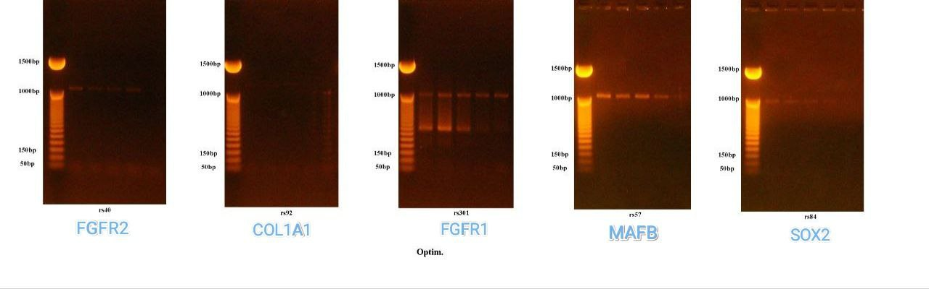
Figure 1: Agaros gel electrophoresis of FGFR2, COL1A1, FGFR1, MAFB and SOX2 genes the electrophoresis was performed using 1.5% agrose gel, 7v/cm for 90 min.

The results of Sanger sequencing revealed the following:
FGFR1: The analysis of FGFR1 gene (rs881301) using Sanger sequencing shows one polymorphism in Class I group and three polymorphism in Class III group. An example of SNP labeled in red rectangle (A8_M13-FB.ab1). Single “T” peak indicative of a T homozygous allele. Single “C” peak indicative of a C homozygous allele. Presence of the “T” and “C” peak indicative of T/C heterozygous allele (C) (Figure 2).
MAFB: All tested samples had unclear readings (Figure 3).
COL1A1: The analysis of COL1A1 gene (rs2249492) using Sanger sequencing shows one polymorphism in Class I group. An example of SNP labeled in red rectangle (1_M13-FB.ab1). The single “A” peak indicated for a C homozygous allele and single “G” peak indicative of A homozygous allele while a presence of the “A” and “G” peak indicative of A/G heterozygous allele (R) (Figure 4).
SOX2: The analysis of SOX2 gene (rs4434184) using Sanger sequencing shows one polymorphism in Class I group and two polymorphism in Class III group. An example of SNP labeled in red rectangle (4_M13-FB.ab1). The single “A” peak indicated for a homozygous allele and single “G” peak indicative of a G homozygous allele while a presence of the “A” and “G” peak indicative of A/G heterozygous allele (R) (Figure 5).
FGFR2: All tested samples had unclear readings (Figure 6).
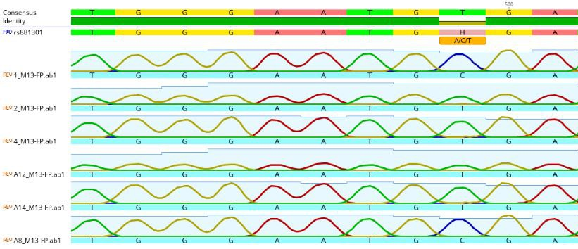
Figure 2: The analysis of FGFR1 gene (rs881301) using Sanger sequencing shows one polymorphism in Class I group and three polymorphism in Class III group. An example of SNP labeled in red rectangle (A8_M13-FB.ab1).
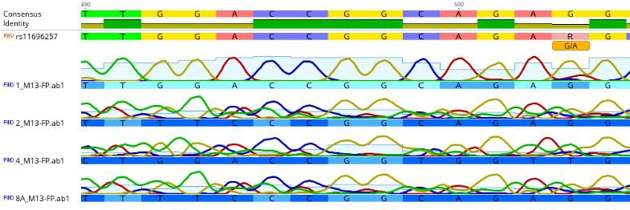
Figure 3: The analysis of MAFB gene (rs11696257) using Sanger sequencing, shows all tested samples had unclear readings.
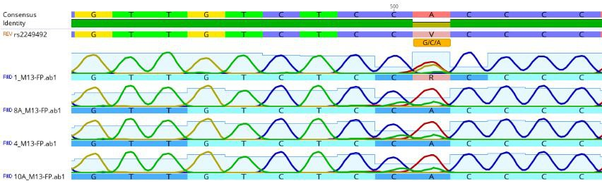
Figure 4: The analysis of COL1A1 gene (rs2249492) using Sanger sequencing shows one polymorphism in Class I group. An example of SNP labeled in red rectangle (1_M13-FB.ab1).
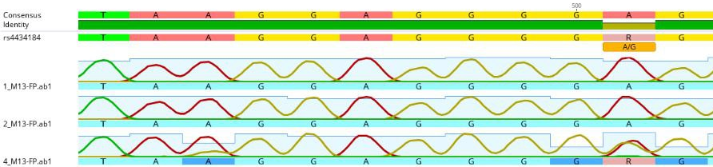
Figure 5: The analysis of SOX2 gene (rs4434184) using Sanger sequencing shows one polymorphism in Class I group and two polymorphism in Class III group. An example of SNP labeled in red rectangle (4_M13-FB.ab1).
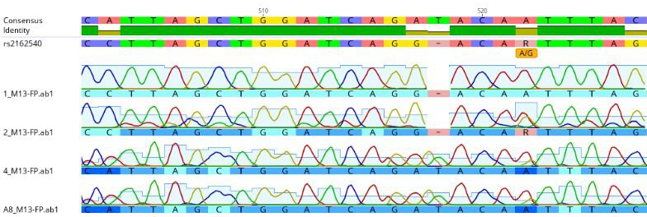
Figure 6: The analysis of FGFR2 gene (rs2162540) using Sanger sequencing shows all tested samples had unclear readings.
Discussion
According to the World Health Organization, malocclusion ranks as the third most prevalent oral health problem worldwide, following dental caries and periodontal disorders ⁽¹⁶⁾. Malocclusion is a condition influenced by various factors, such as genetic inheritance, genetic mutations, age, gender, ethnicity, dental abnormalities, congenital diseases, muscle disorders, hormonal imbalances, and behavioral aspects ⁽¹⁷⁾.
The causes of malocclusion are multifactorial, with genetic, environmental, and ethnic factors being the primary contributors. The presence of certain malocclusion types, such as Class III relationships, within families highlights a significant genetic link to the condition ⁽¹⁸⁾. Conversely, the soft tissues, bones, and nearby dentitions undergo functional adaptations in response to environmental conditions, leading to diverse malocclusion problems ⁽¹⁸⁾.
Cephalometric research suggests that accurate predictions of growth and orthodontic therapy effects are most beneficial for growing Class II and Class III patients. According to Björk and Skieller's research, mandibular growth rotations can be complicated and difficult to treat clinically, especially in people who have a high mandibular plane angle ⁽¹⁹⁾. The anterio-posterior aspect of the malocclusion is determined by the SNA, SNB, and ANB angles, which relate the maxillary and mandibular skeletal bases. In 1952, Riedel first suggested using this measurement to establish a relationship of the maxilla to the cranium. Adult Caucasians typically have two degrees of ANB. Class II skeletal discrepancies are indicated by significant positive numbers, while Class III discrepancies are indicated by large negative numbers ⁽¹⁹⁾.
Previous research suggested a correlation between different genes, facial morphology, and maxillary or mandibular discrepancy ^{(20,21)}. The phenotypic genetic tendency of the maxilla and mandible has been related to several risk loci. Numerous gene loci, including the COL1A1 gene ^{(22,23,24)},the SOX2 gene ⁽¹³⁾, the fibroblast growth factor 1 (FGFR1) gene ⁽²⁵⁾, the fibroblast growth factor 2 (FGFR2) gene ^{(22,23,26)}, and MAFB gene ⁽¹³⁾, have been linked to class III malocclusion and mandibular prognathism.
The COL1A1 gene's genetic polymorphism has a clinically significant effect on bone remodeling ⁽²⁷⁾. The periosteum of the mandibular bone, the mandibular condylar cartilage, the perichondrium of Meckel's cartilage, and the bone collar of the cranial base cartilage all contain COL1A1 in midterm human fetuses ^{(28).} Notably, COL1A1 was linked to both class II and class III malocclusions, implaying that this gene is important for influencing craniofacial development, particularly in the sagittal dimension. One theory is that the COL1A1 gene has various SNPs that may cause one class of malocclusion to have a more effective isoform or higher expression, while the other class has a more inactive isoform or lower expression ^{(22,23)}. Our results show that Class III malocclusion and COL1A1 are unrelated because the analysis of COL1A1 gene using Sanger sequencing showed one polymorphism in Class I group only.
At 3q26, there is a gene named SOX2 that is highly conserved ⁽²⁹⁾ A number of craniofacial abnormalities, including cleft palate and ocular malformations, have been linked to SOX2, which is crucial in sustaining stem cell pluripotency and neurogenesis ⁽³⁰⁾. Growth retardation, sensorineural hearing loss, mental retardation, and cleft palates are among the many of the extra-ocular symptoms that SOX2 mutations have been linked to in a growing number of studies, this suggests that the craniofacial complex is directly affected ⁽³⁰⁾. According to Weaver research, the SOX2 (rs4434184) mutation increases the risk of a Class III phenotype by 2.15 to 1.7 times ⁽¹³⁾, also our results show that SOX2 rs4434184 is associated with class III skeletal malocclusion.
Furthermore, this study explores the correlation between the FGFR1 gene and Class III malocclusion, considering its role in postnatal growth, both normal and aberrant. The fibroblast growth factor/fibroblast growth factor receptor (FGF/FGFR) is a tyrosine kinase signaling pathway that has a fundamental role in many biologic processes including embryonic development, tissue regeneration, and angiogenesis ⁽³¹⁾. Numerous research have shown how genes linked to uncommon diseases may shed light on lone characteristics, and FGFs and FGFRs may be involved in lone kinds of skeletal Class III malocclusion ⁽³²⁾. When the skull and face are developing, FGFR1 has a substantial impact on the craniomaxillofacial bone, muscle, palate, teeth, and submandibular salivary gland ⁽³³⁾. In the current study, the rs881301 in FGFG1 was investigated, and it has been shown to be related to skeletal Class III malocclusion. Weaver additionally found the same SNP in American people who had Class III skeletal malocclusion and maxilla-mandibular deviations ⁽¹³⁾.
A transcription factor known as MAFB from the big MAF subfamily ( MAFA, cMAF, MAFB, and NRL) binds to the MARE DNA element ⁽³⁴⁾. It has been determined that the hematological system, the kidney, the lens, the retina, the pancreatic islet cells, and the brain all depend on the basic leucine zipper (bZIP) transcription factor, which is encoded by the gene MAFB. However, study by Beaty et al. indicated that MAFB mRNA and protein expression has been shown in both craniofacial neuroectoderm and neural-crest formed from mesoderm between embryonic days 13.5 and 14.5, suggesting that the gene may be connected with non-syndromic cleft lip or palate (NSCL/P) ⁽³⁵⁾.
The development process is significantly influenced by fibroblast growth factor receptor type 2 (FGFR2). There are two splice versions of it, IIIb and IIIc, just as FGFR1 and FGFR3 ⁽³⁶⁾. Osteoblasts' ability to generate new bone is positively regulated by FGFR2 signaling ⁽³⁷⁾. The expression of FGF family members that are locally expressed during bone formation is necessary for bone growth. Mesenchymal cells & osteoblasts in bone have FGF2 transcripts ⁽³⁸⁾.
All tested samples had unclear readings for both MAFB and FGFR2 genes. The majority of sequencing errors for Sanger sequencing are besides low DNA quality, the main reason sequencing fails is the wrong concentration of DNA template in the template + primer mix. Furthermore, the adding of wrong primer or a poor primer to the template, inaccuracies during the amplification phase, random variation, and sample contamination will effect on the result. Additionally, sequencing errors often start to build up near the conclusion of lengthy sequences due to reduced intensities and missing termination variants ⁽³⁹⁾.
The primary limitation of our study was the small sample size, which is important to investigate any potential associations between SNPs and specific traits. Additional research with larger samples and other demographic profiles is necessary in order to validate our results.
Conclusion
The study suggests a potential association between genetic alterations in SOX2 and FGFR1 and occurrence of Class III malocclusion. Nevertheless, further investigation utilizing a larger sample size is required to validate these findings.
Conflict of interest
The authors have no conflicts of interest to declare.
Author contributions
AMB and MA; study conception and design. AMB; data collection. AMB and MA; Methodology. AMB and MA; statistical analysis and interpretation of results. AMB, MA and EA; Writing - review & editing. Supervision; MA and EA. All authors reviewed the results and approved the final version of the manuscript to be published.
Acknoledgement and funding
There was no external support for this study.
Informed consent
Informed consent was obtained from all individuals or their guardians included in this study.
References
- Claudino D, Traebert J. Malocclusion, dental aesthetic self-perception and quality of life in a 18 to 21 year-old population: A cross section study. BMC Oral Health. 2013;13:2-7. https://doi.org/10.1186/1472-6831-13-3
- Ali MA, Yassir YA. Mandibular Clinical Arch Forms in Iraqi Population: A National Survey. Diagnostics. 2022;12:1-15. https://doi.org/10.3390/diagnostics12102352
- Najm AA, Mahdi AS, Al-Sudani RJ. Prevalence of Dental Anomalies among Iraqi Dental Students. J Baghdad Coll Dent. 2016;28:72-6. https://doi.org/10.12816/0033214
- Moreno Uribe LM, Miller SF. Genetics of the dentofacial variation in human malocclusion. Orthod Craniofacial Res. 2015;18:91-9. https://doi.org/10.1111/ocr.12083
- Staudt CB, Kiliaridis S. Different skeletal types underlying Class III malocclusion in a random population. Am J Orthod Dentofac Orthop. 2009;136:715-21. https://doi.org/10.1016/j.ajodo.2007.10.061
- Abdulhussein ZA, Aksoy A. Compliance of Patients with Class III Malocclusion to Orthodontic Treatment. J Baghdad Coll Dent. 2022;34:12-24. https://doi.org/10.26477/jbcd.v34i1.3087
- Mossey PA. The heritability of malocclusion: Part 1--Genetics, principles and terminology. Br J Orthod. 1999;26:103-13. https://doi.org/10.1093/ortho/26.2.103
- Xue F, Wong RWK, Rabie ABM. Genes, genetics, and Class III malocclusion. Orthod Craniofacial Res. 2010;13:69-74. https://doi.org/10.1111/j.1601-6343.2010.01485.x
- Hussein AS, Porntaveetus T, Abid M. The association of polymorphisms in BMP2/MYO1H and skeletal Class II div.1 maxillary and mandibular dimensions. A preliminary 'report. Saudi J Biol Sci. 2022;29:1-7. https://doi.org/10.1016/j.sjbs.2022.103405
- Manolio TA. Genomewide Association Studies and Assessment of the Risk of Disease. N Engl J Med. 2010;363:166-76. https://doi.org/10.1056/NEJMra0905980
- Weiler CA, Drumm ML. Genetic influences on cystic fibrosis lung disease severity. Front Pharmacol. 2013;4:1-19. https://doi.org/10.3389/fphar.2013.00040
- Strauss JF, Romero R, Gomez-Lopez N, Haymond-Thornburg H, Modi BP, Teves ME, et al. Spontaneous Preterm Birth: Advances toward the Discovery of Genetic Predisposition. Am J Obstet Gynecol. 2018;218:294-314. https://doi.org/10.1016/j.ajog.2017.12.009
- Weaver CA. Candidate Gene Analysis of 3D Dental Phenotypes in Patients with Malocclusion. University of Iowa; 2014.
- Little J, Higgins JPT, Ioannidis JPA, Moher D, Gagnon F, Elm EV, et al. STrengthening the REporting of genetic association studies (STREGA)- An extension of the STROBE statement. Genet Epidemiol. 2009;33:581-98. https://doi.org/10.1002/gepi.20410
- Steiner CC. Cephalometrics for you and me. Am J Orthod. 1953;39:729-55. https://doi.org/10.1016/0002-9416(53)90082-7
- Guo L, Feng Y, Guo HG, Liu BW, Zhang Y. Consequences of orthodontic treatment in malocclusion patients: Clinical and microbial effects in adults and children. BMC Oral Health. 2016;16:1-7. https://doi.org/10.1186/s12903-016-0308-7
- Saghiri MA, Eid J, Tang CK, Freag P. Factors influencing different types of malocclusion and arch form - A review. J Stomatol Oral Maxillofac Surg. 2021;122:185-91. https://doi.org/10.1016/j.jormas.2020.07.002
- Heimer MV, Tornisiello Katz CR, Rosenblatt A. Non-nutritive sucking habits, dental malocclusions, and facial morphology in Brazilian children: A longitudinal study. Eur J Orthod. 2008;30:580-5. https://doi.org/10.1093/ejo/cjn035
- Björk A, Skieller V. 'Normal and abnormal growth of the mandible. A synthesis of longitudinal cephalometric implant studies over a period of 25 years', Eur J Orthod. 1983;5:1-46. https://doi.org/10.1093/ejo/5.1.1
- Liu H, Wu C, Lin J, Shao J, Chen Q, Luo E. Genetic etiology in nonsyndromic mandibular prognathism. J Craniofac Surg. 2017;28:161- 69. https://doi.org/10.1097/SCS.0000000000003287
- Cunha A, Nelson-Filho P, Marañón-Vásquez GA, Ramos AGC, Dantas B, Sebastiani AM, et al. Genetic variants in ACTN3 and MYO1H are associated with sagittal and vertical craniofacial skeletal patterns. Arch Oral Biol. 2019;97:85-90. https://doi.org/10.1016/j.archoralbio.2018.09.018
- Da Fontoura CSG, Miller SF, Wehby GL, Amendt BA, HoltonNE, Southard TE, et al. Candidate gene analyses of skeletal variation in malocclusion. J Dent Res. 2015;94:913-20. https://doi.org/10.1177/0022034515581643
- Ardani IGAW, Budipramana M, Rachmawati E, Nugraha AP, Ardana AKKG, Budhy TI, et al. COL1A1 and FGFR2 Single- Nucleotide Polymorphisms Found in Class II and Class III Skeletal Malocclusions in Javanese Population. Eur J Dent. 2022;17:183-90. https://doi.org/10.1055/s-0042-1744371
- Milosevic O, Nikolic N, Carkic J, Majstorović N, Glisic B, Milasin J. Analysis of Col1a1 and Mmp9 Single Nucleotide Polymorphisms in Mandibular Prognathism. Genetika. 2022;54:777-86. https://doi.org/10.2298/GENSR2202777M
- Xiong X, Li S, Cai Y, Chen F, Liu J. Targeted sequencing in FGF/FGFR genes and association analysis of variants for mandibular prognathism. Med. 2017;96:1-7. https://doi.org/10.1097/MD.0000000000007240
- Jiang Q, Mei L, Zou Y, Ding Q, Cannon RD, Chen H, et al. Genetic Polymorphisms in FGFR2 Underlie Skeletal Malocclusion. J Dent Res. 2019;98:1340-7. https://doi.org/10.1177/0022034519872951
- Luo S, Long X, Deng M, Meng Q, Ke J, Guo H. Association of COL1A1 polymorphism with subchondral bone degeneration of the temporomandibular joint. Int J Oral Maxillofac Surg. 2016;45:1551-5. https://doi.org/10.1016/j.ijom.2016.06.010
- Shibata S, Sakamoto Y, Baba O, Qin C, Murakami G, Cho BH. An immunohistochemical study of matrix proteins in the craniofacial cartilage in midterm human fetuses. Eur J Histochem. 2013;57:262-70. https://doi.org/10.4081/ejh.2013.e39
- Mandalos N, Saridaki M, Harper JL, Kotsoni A, Yang P, Economides AN, et al. Application of a Novel Strategy of Engineering Conditional Alleles to a Single Exon Gene, Sox2. PLoS One. 2012;7:1-9. https://doi.org/10.1371/journal.pone.0045768
- Langer L, Sulik K, Pevny L. Cleft palate in a mouse model of SOX2 haploinsufficiency. Cleft Palate-Craniofacial J. 2014;51:110-14. https://doi.org/10.1597/12-260
- Chae YK, Ranganath K, Hammerman PS, Vaklavas C, Mohindra N, Kalyan A, et al. Inhibition of the fibroblast growth factor receptor (FGFR) pathway: The current landscape and barriers to clinical application. Oncotarget. 2017;8:16052-74. https://doi.org/10.18632/oncotarget.14109
- Cruz CV, Mattos CT, Maia JC, Granjeiro JM, Reis MF, Musha JN, et al. Genetic polymorphisms underlying the skeletal Class III phenotype. Am J Orthod Dentofac Orthop. 2017;151:700-7. https://doi.org/10.1016/j.ajodo.2016.09.013
- Nie X, Luukko K, Kettunen P. FGF signalling in craniofacial development and developmental disorders. Oral Dis. 2006;12:102-11. https://doi.org/10.1111/j.1601-0825.2005.01176.x
- Cuevas VD, Anta L, Samaniego R, Zavalza EO, de la Rosa JV, Baujat G, et al. MAFB Determines Human Macrophage Anti-Inflammatory Polarization: Relevance for the Pathogenic Mechanisms Operating in Multicentric Carpotarsal Osteolysis. J Immunol. 2017;198:2070-81. https://doi.org/10.4049/jimmunol.1601667
- Beaty TH, Murray JC, Marazita ML, Munger RG, Ruczinski I, Hetmanski JB, et al. A genome-wide association study of cleft lip with and without cleft palate identifies risk variants near MAFB and ABCA4. Nat Genet. 2010;42:525-9. https://doi.org/10.1038/ng.580
- Eswarakumar VP, Monsonego-ornan E, Pines M, Antonopoulou I, Gillian M. The IIIc alternative of Fgfr2 is a positive regulator of bone formation. Development. 2002;129:3783-93. https://doi.org/10.1242/dev.129.16.3783
- Xiao L, Naganawa T, Obugunde E, Gronowicz G, Ornitz DM, Coffin JD, et al. Stat1 controls postnatal bone formation by regulating fibroblast growth factor signaling in osteoblasts. J Biol Chem. 2004;279:27743-52. https://doi.org/10.1074/jbc.M314323200
- Kim HJ, Rice DPC, Kettunen PJ, Thesleff I. FGF-, BMP- and Shh-mediated signalling pathways in the regulation of cranial suture morphogenesis and calvarial bone development. Development. 1998;125:1241-51. https://doi.org/10.1242/dev.125.7.1241
- Kircher M, Kelso J. High-throughput DNA sequencing - Concepts and limitations. BioEssays. 2010;32:524-36. https://doi.org/10.1002/bies.200900181

تعدد الأشكال الجينية للمرضى الذين يعانون من سوء الإطباق من الدرجة الثالثة. دراسة تجريبية
اية محمد بهيه, مشرق فوزي عبد, الهام الصحافي
المستخلص:
خلفية: قد تفسر تفاعلات العوامل الوراثية والبيئية التباين في التعبير عن سوء الإطباق. لا يكمن التعقيد المسبب للمرض في التعبير غير المتوقع فحسب ، بل يكمن أيضا في الطيف الواسع من تباين الوجه والأسنان الموجود في الأفراد المصابين. يفسر هذا التعقيد جزئيا سبب توجيه معظم مناهج علاج سوء الإطباق إلى الأعراض بدلا من المسببات. ومع ذلك ، على الرغم من هذا التعقيد ، فإن دراسة مسببات سوء الإطباق أمر أساسي لفهم البيولوجيا الكامنة وراء النمو القحفي الوجهي وعلاقات الأسنان. إن فهم البيولوجيا سيساعد على التقدم نحو العلاج الفعال والوقاية ، وبالتالي تقليل عبء هذه الحالة. الأهداف: تم إعداد هذه الدراسة للتحقيق في ارتباط تعدد الأشكال في الجينات المختلفة (rs2249492 in COLA1A, rs4434184 in SOX2, rs2162540 in FGFR2, rs11696257 in MAFB, and rs881301 in FGFR1) مع سوء الإطباق من الدرجة الثالثة. المواد والطرق: تم تضمين ما مجموعه 10 مرضى ، منهم 5 يعانون من الهيكل العظمي من الدرجة الأولى و 5 مع سوء إطباق الهيكل العظمي من الدرجة الثالثة ، في هذه الدراسة. تم جمع عينات الحمض النووي اللعابي وتحليلها باستخدام تسلسل سانجر. تم إجراء التتبع الرقمي على الصور الشعاعية الجانبية للرأس باستخدام برنامج اوتوكاد للرقمنة لتقييم العلاقة الأمامية الخلفية والعمودية لقوس الفك العلوي والفك السفلي.
SOX2 و FGFR1الخلاصة: قد يكون سبب سوء الإطباق من الفئة الثالثة هو الاختلافات الجينية في جينات وفقا لهذه الدراسة. للتحقق من هذه النتائج هناك حاجة إلى مزيد من الدراسات التي تنطوي على حجم عينات أكبر

